**WHY TO SHIFT FROM CONTINUOUS AND DISCRETE?**

Before answering the above question, you have clear about the difference between the continuous and discrete time signals.

**CONTINUOUS TIME SIGNAL**

A signal which is defined for all the values of instantaneous time(t) is called continuous time signal. Meaning there are no break in the signal. It should be look like this as shown in the figure:-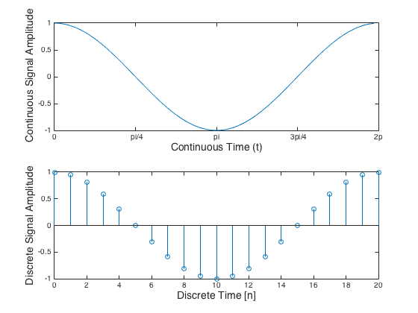

Reference of image:­ [2.1: Top: An illustration of a continuous time 100Hz. The signal ...](https://www.researchgate.net/figure/1-Top-An-illustration-of-a-continuous-time-100Hz-The-signal-is-continuous-ie-there_fig1_309728584)

**DISCRETE TIME SIGNAL**

A signal which is defined only at a discrete interval of time(n) is called discrete time signal. As shown in the above image….

1. For discrete time signal time is discrete but amplitude is continuous.
2. For digital time signal both time and amplitude is discrete.

**You can see it in the below image**.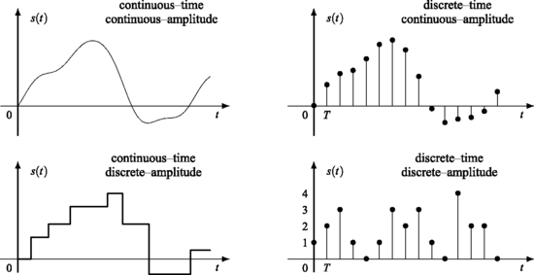

Reference of image:- [Introduction | SpringerLink](https://link.springer.com/chapter/10.1007/978-0-85729-464-7_1)

**Now, the question arises why we shift to discrete time signal?**

The answer is very simple, physically we implement and control things using digital computers. For conceptual understanding we use continuous time signal but physically we use discrete time signal.

All digital computers are discrete systems and performs operation on discrete data.

We can easily convert the continuous time signal to discrete by just multiplying the continuous input signal to the pulse/sampling time of the system.

Sampling time is the time interval between successive samples, also called the **sampling** interval or the **sampling period** .

But when you go from continuous to discrete time signal then, there is some disadvantages of it.

1. ***Loss of information***

Some of the important information while sampling process is lost as shown in the figure but it can minimized by reducing the time intervals between the two successive samples.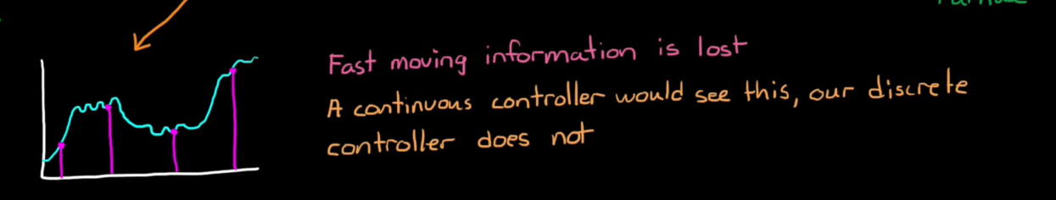

1. ***Quantization error***

The rounding off analog value to closest digital value.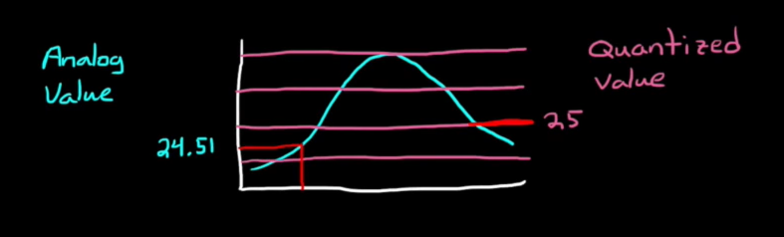

1. ***Delays***

There is a delay occurs in between the two measurements due to the conversinon, algorithms and actuation.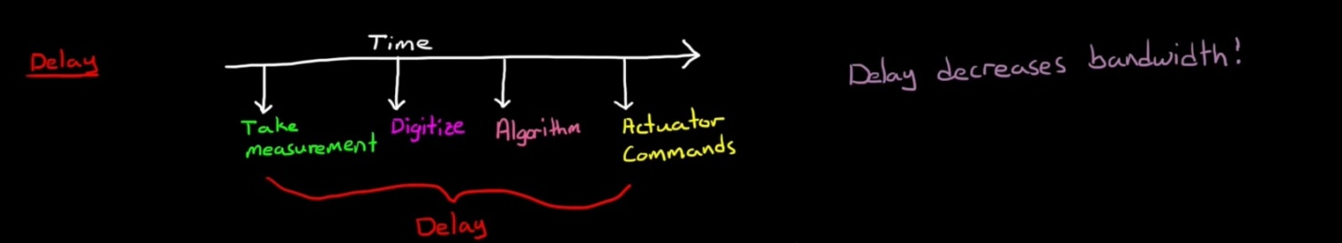

Reference of images:- brian douglas youtube.